

The HAREM Study (Had Appendicitis and
Resolved/Recurred Emergency Morbidity/Mortality):
A snapshot audit of the presentation and management of acute appendicitis in the United Kingdom during the COVID-19 pandemic.

Protocol version: 4.2
Protocol date: 23/4/2020
Acronym/ short study title: COVIDHAREM
Twitter: @COVIDHAREM
E-mail: covidharem@asgbi.org.uk

Chief Investigators: Gill Tierney, Consultant Surgeon, General and Coloproctology, University Hospitals of Derby and Burton NHS Foundation Trusts; Honorary Assistant Professor, University of Nottingham. gillian.tierney1@nhs.net. Susan Moug, Consultant Surgeon, Royal Alexandra Hospital Paisley; Honorary Professor, University of Glasgow. susanmoug@nhs.net

Trial Steering Group:
H Boyd-Carson, H Javanmard, P Daliya, A Adiamah, L Pearce, J Cornish, R Clifford, S Richards, S Hare, S Lockwood, I Anderson, J Lund, M, Hollyman, S Moug, G Tierney.


Supported by The Association of Surgeons of Great Britain and Ireland.
Study Summary.

Study Title | The HAREM Study (Had Appendicitis and Resolved/Recurred Emergency Morbidity/Mortality).
Internal ref. no. (or short title) | The HAREM Study.
Study Design | Observational.
Study Participants | An adult (over age of 18 years) diagnosed with Acute Appendicitis (AA) in secondary care.
Planned Size of Sample | n/a. During COVID-19 the number of AA has significantly dropped which is the impetus for this study.
Follow up duration | 3 months.
Planned Study Period | Will be determined by date of COVID-19 Lockdown (23rd March 2020) to at least 3 weeks after routine elective surgery re-started (dependent on UK Government Lockdown lifted so end point flexible).
Research Question/ Aim(s) | This study aims to quantify the number of patients presenting to acute surgical units with AA and for those operated on, a negative appendicectomy rate of <20%. Demographics, type of presentation and treatment will all be recorded in addition to 90-day outcomes.

Role of Study Sponsor and Funder.

Derby and Burton NHS Foundation Trust as the employer of the CI will act as sponsor of this study. Each site participating will be responsible for registering the study as a service evaluation and completing the local requirements. The Association of Surgeons of Great Britain and Ireland support this study. There is no funding for this study at the time of writing although funding applications may be submitted in the future.

Roles and Responsibilities of Trial Steering Group, Patient and Public Involvement (PPI) and Collaborators.

Trial Steering Committee
This group are responsible for the development of the protocol and design of the online REDCap database. They will also contribute to data collection at their own sites locally and encourage UK participation via their social media and trainee and non-trainee collaboratives. Overall, as this is an observational study, minimal safety issues are expected.

PPI Group
Due to the rapid onset of this pandemic, it is not possible to develop a PPI group of patients to provide input to this study. We will distribute the results around PPI groups when completed.

Collaborators
All local PI and their teams will form The HAREM Study Collaborative. They will be published as individual authors under their site and The HAREM Collaborative. There is no minimal data entry required to achieve authorship, but validation must be performed. Each PI should consider an appropriate number of authors that have contributed significantly to their local data collection.

Background.

Acute appendicitis (AA) is the most common general surgical emergency worldwide (1) and contributes significantly to the Emergency General surgery (EGS) workload. With increasing burden placed on the health service from rising cases of COVID-19 (CV-19), acute presentations to the EGS service have significantly dropped across the UK (2). Irrespective of the ideal treatment (conservative versus surgical) significant morbidity and mortality from appendicitis is universally accepted as low (3, 4). In contrast, greater morbidity and mortality have been reported when treatment is delayed or patients present late and include: perforation; peritonitis; intra-abdominal sepsis; septic shock and multi-organ failure (5).

Currently in the clinical setting of a CV-19 pandemic, concern has been raised by leading UK professional bodies that there is likely to be an increased number of delayed presentations of surgical pathology, including AA. This may lead to an increase in significant morbidity and mortality, which will place further burdens on the surgical and anaesthetic/ critical care workloads. Currently this burden is being minimised with the four surgical colleges releasing CV-10 guidance that has advised antibiotic management of AA as first line treatment, with open surgery only indicated when such conservative measures fail (6).

Therefore, it can be seen that there is a clear and urgent need to capture and define outcomes of AA across the UK in the setting of CV-19.

Aim and Outcomes.

Aim: This study aims to quantify the number of patients presenting to hospitals, in the United Kingdom, with acute appendicitis during the CV-19 pandemic.

Primary outcome:
- Number of patients diagnosed with acute appendicitis in the UK from date of CV-19 lockdown (Monday 23rd March 2020) and for those operated on, a negative appendicectomy rate of <20% will be taken as the standard.

Secondary outcomes:
- Antibiotic duration
- Operative rate (and surgical approach)
- Complication rate
- Admission to critical care (Level 2 or 3)
- 30 and 90-day Mortality rate
- CV-19 positive
- Readmission rate within 3 months
- Length of hospital stay

Methods.

Study design: a multicentre, UK observational study.

Study setting: hospitals in the UK that provide emergency care for patients diagnosed with Acute Appendicitis (AA) have been invited to participate.

At least 30 hospitals have expressed interest across the UK. All of these sites are established recruiters to surgical trials with more sites expected to participate through established research UK collaboratives.

Inclusion criteria: All patients aged 18 years or over treated/diagnosed (either clinically and/ or radiologically) with acute appendicitis in a UK secondary care setting.

Exclusion criteria: Any patient under 18 years of age at time of diagnosis of AA. Any patient who subsequently goes on to have their diagnosis changed from AA to another acute condition.

Patient identification: Patients will be screened for inclusion criteria by the local team. It is likely that this will occur in different secondary surgical care settings: emergency department; surgical assessment unit (SAU); Hot Clinics.

Local approvals: The Centre lead at each participating site is responsible for all members of their team have up to date GCP training and will have local responsibility for data quality and entry. They will obtain necessary local approvals in line with their hospital’s regulations and will be required to confirm that a local approval is in place at the time of uploading each patient record to the study database. REDcap accounts will not be issued until evidence is provided via hospital local leads that the following approvals are in place at each centre:

- Successful registration of HAREM at the hospital site
- Caldicott Guardian permission for data to be submitted to REDcap
Centre leads should discuss with their head of research whether it is possible to expedite the approvals process in view of the urgency of global pandemic. It should be highlighted that this is an investigator-led, non-commercial, observational (no changes to normal patient care) study with only routinely available non-identifiable data will being collected. The project can be registered as either a service evaluation or clinical audit.

Prior to formal local study approval, if permitted, collaborators may prospectively collect data on hard copy case report forms, but this should not be uploaded to the REDCap database until approval is confirmed.

Data collection period: Data collection will commence from date approvals are in place with retrospective data starting from the date of the CV-19 Government Lockdown (23/03/2020). The remainder of the data will be collected prospectively with the end point being three weeks after the date the UK Government lift the Lockdown (partially or completely). The estimated total data collection period is a minimum of 9-10 weeks (excluding follow-up), but the HAREM Study reserve the right to change or extend this period in line with UK Government Lockdown Policies. This will allow at least a 3-phase analysis of AA: Phase 1 Lockdown (23rd March 2020 to 16th April 2020); Phase 2 Continuation (17th April 2020 to 7th May 2020 potentially) and Phase 3 Re-opening (7th May 2020 potentially and at least 3 weeks beyond).
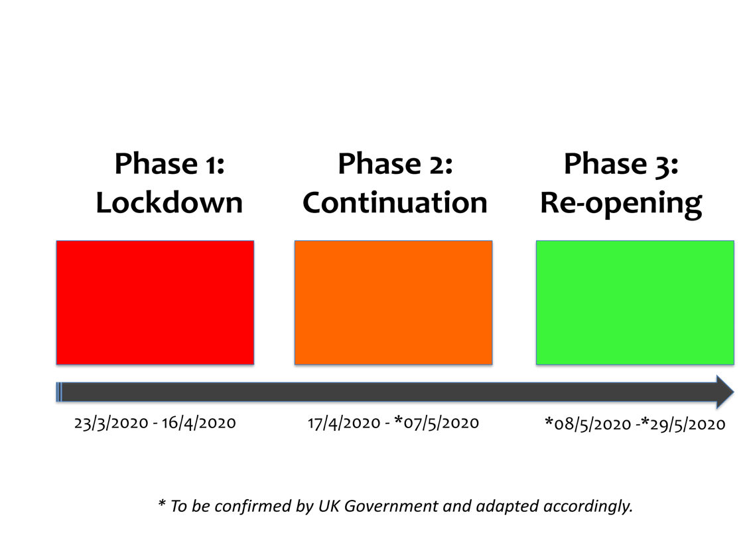
Data collection: At registration, the Centre lead will provide local approvals to the steering committee. Data collection will be using the form presented in Appendix A. Hospital or NHS number will not be entered into this form, but will be kept separately by Centre lead with a key sheet. Data can be collected both retro- and prospectively. Data will be entered and stored online through a secure server running the Research Electronic Data Capture (REDCap) web application. REDCap allows collaborators to enter and store data in a secure system. The local PI at each participating site will be provided with REDCap project server login details, allowing them to securely submit data on to the REDCap system.

Only anonymised data will be uploaded to the database. No patient identifiable data will be collected.

Validation: A data validator should be allocated at each centre. Validation will be performed on 25% of data fields for 10% of cases. The validated fields will include key demographic and outcome data.

Analysis: A detailed statistical analysis plan will be written. Reports will include description of the primary and secondary outcomes in the cohort. Analysis may be performed on the 3 different time phases, depending on numbers uploaded. Hospital-level data will not be released or published. Comparison to previously published data on appendicitis outcomes will be used (RIFT Study Group and GlobalSurg Collaboratives) [1, 7].

Authorship and Dissemination

Authorship: Local HAREM team collaborators and data validators will be eligible for PubMed-citable co-authorship as collaborators, provided a validated dataset is returned by the closing date of the project. There is no maximum of collaborators per local team with one being an independent validator. Centres with >5% missing data will be excluded from the analysis and the contributing local team removed from the authorship list. Example authorship can be found at: https://www.ncbi.nlm.nih.gov/pubmed/31188201.

Following analysis, each unit will retain ownership of their own data and a summary of national outcomes will be provided to each site.

Dissemination: All data will be reported as a whole cohort. The project will be submitted for presentation at national and international surgical conferences. Manuscript(s) will be prepared following close of the project. Individuals in this collaboration have published extensively.

Data will be made available to future studies in the ongoing research surrounding CV-19 and emergency surgery in the interest of encouraging worldwide research collaboration.

References

- GlobalSurg Collaborative. Mortality of emergency abdominal surgery in high‐, middle‐ and low‐income countries. Br J Surg 2016; 103: 971–988.
- Public Health England. Emergency Department Syndromic Surveillance System: England. https://assets.publishing.service.gov.uk/government/uploads/system/uploads/attachment_data/file/879585/EDSSSBulletin2020wk15.pdf. Accessed 18.4.20
- Goldacre MJ, Duncan ME, Griffith M, et al. Trends in mortality from appendicitis and from gallstone disease in English populations, 1979–2006: study of multiple-cause coding of deaths. Postgraduate Medical Journal 2011;87:245-250.
- Di Saverio S, Podda M, De Simone B et al. Diagnosis and treatment of acute appendicitis: 2020 update of the WSES Jerusalem gudielines. World J Emerg Surg 2020. https://doi.org/10.1186/s13017-020-00306-3
- Bickell NA, Aufses AH, Rojas M, Bodian C. How time affects the risk of rupture in appendicitis. J Am Coll Surg 2006;202: 401-6.
- The Association of Surgeons of Great Britain and Ireland. 2nd Update Intercollegiate General Surgery Guidance on COVID-19 5 April. https://www.asgbi.org.uk/userfiles/file/covid19/2nd-update-intercollegiate-general-surgery-guidance-on-covid-19-6-april-_-1.pdf. Accessed 19.4.20
- RIFT Study Group on behalf of the West Mdilands Research Collaborative. Evaluation of appendicitis risk prediction models in adults with suspected appendicitis. Brit J Surg 2020. 107: 73-86.

Appendix A: Data Collection Sheet

Q1 | Study ID
Q2 | Age at admission to study (years)
Q3 | Sex | Male Female
Q4 | Comorbidities
  BMI>40 Y/N
  Diabetes Y/N
  COPD Y/N
  Current smoker Y/N
  Asthma Y/N
  MI Y/N
  Hear Failure Y/N
  Immunosuppression Y/N
  Dementia Y/N
Q5 | ASA | I II III IV V
Q6 | Frailty Score | 1 2 3 4 5 6 7 8 9
Q7 | Duration of symptoms prior to admission | Hours Days
Q8a | Primary care visit prior to admission | Yes No
Q8b | Grade of primary care practitioner | GP Nurse Practitioner  Other: .
Q9a | Antibiotics initiated in primary care | Yes No
Q9b | Choice of antibiotic | Nitrofurantoin Metronidazole  Trimethoprim Ciprofloxacin  Co-amoxiclav Cefuroxime  Other: .
Q12a  Q12b | Date of surgical assessment  Time of surgical assessment | DD/MM/YYYY  00:00
Q13 | Grade of assessing surgeon | SHO SPR Consultant  Other: .
Q14a | How was the diagnosis reached | Clinically Bloods Imaging
Q14b | What imaging was used? | USS CT MRI None
Q15a | Admitted following initial assessment? | Yes  No- brought back for imaging  No- brought back for repeat clinical assessment  No- discharged with antibiotics
Q15b | Admission date (if different to assessment date) | DD/MM/YYYY
Q16a | Initial WCC
Q16b | Initial Neutrophil count
Q16c | Initial Lymphocyte count
Q16d | Initial CRP
Q17 | Temperature on presentation | <37.4 37.5-37.9 38.0-38.4 >38.5
Q18 | Heart rate on presentation | <49 50-70 71-90 91-110 >111
Q19 | Appendicitis inflammatory response score
Q20 | Adult appendicitis score
Q21a | Was COVID suspected on first presentation | Yes No
Q21b | If yes, were they assessed in a dedicated COVID assessment area | Yes No
Q21c | What tests were carried out to confirm COVID status | CXR CT chest COVID swab
Q21d | COVID confirmed on | CXR Y/N/Not performed  CT chest Y/N/Not performed
Q21e | COVID swab | Positive/Negative/Not performed
Q22 | Confirmed appendicitis on CT report | Yes No
Q23 | Features of appendicitis present on CT | Fecolith present Y/N/Not reported  Diameter of appendix mms  Pericaecal inflammatory change Y/N/Not reported  Free fluid Y/N/Not reported  Perforation Y/N/Not reported  Abscess Y/N/Not reported  Size of abscess cms
Q24 | Confirmed appendicitis on ultrasound report | Yes No
Q25 | Features of appendicitis present on USS | Appendix appearance  normal/ abnormal /not seen  Surrounding echogenic fat  Y/N/Not reported  Free fluid Y/N/Not reported
Q26 | Antibiotic treatment | Name Dose  Route Start date  Start time Stop date  Stop time
Q27a | Antibiotic switch | Yes No
Q27b | Rationale | Ineffective  PO switch  Microbiology Advice  Other: .
Q28 | Second line antibiotic treatment | Name Dose  Route Start date  Start time Stop date  Stop time
Q29a | Interventional radiology drain placed | Yes No
Q29b | Reason for placement | Abscess on presentation  Antibiotics ineffective  Represented with abscess/collection
Q29c | Form of imaging | USS guided CT guided
Q29d | Date of drainage | DD/MM/YYYY
Q29e | Time of drainage | 00:00
Q29f | Date of drain removal | DD/MM/YYYY
Q30a | Operation required | Yes No
Q30b | Date decision to operate made | DD/MM/YYYY
Q30c | Operation date | DD/MM/YYYY
Q30d | Time patient sent for | 00:00
Q30e | Anaesthetic start time | 00:00
Q30f | Anaesthetic end time | 00:00
Q30g | Operation start time | 00:00
Q30h | Operation end time | 00:00
Q30i | Grade of operating surgeon | SHO SPR consultant  Other: .
Q30j | Grade of assisting surgeon | SHO SPR consultant  Other: .
Q30k | Route | Open via RIF  Open via midline  Laparoscopic  Laparoscopic converted to open via RIF  Laparoscopic converted to open via midline
Q30l | Operation performed | Appendicectomy  Right hemicolectomy  Washout only  Stoma  Other: .
Q30m | Post op level of care | Ward Level 2 care Level 3 care
Q31a | Operative findings -appendix | Normal Inflamed  Perforated Gangrenous
Q31b | Operative findings- free fluid | None Serous  Pus Fecal matter
Q31c | Operative findings- associated abscess | Yes No
Q32 | Method of base closure | Endoloops Staples  Sutured
Q33 | Histology | Normal  Acute appendicitis  Malignancy  Other: .
Q34 | Complications | Collection Y/N  Ileus Y/N  Wound infection (requiring abx) Y/N  Wound infection (requiring drainage) Y/N  HAP (requiring oral abx) Y/N  HAP (requiring IV abx) Y/N  MI Y/N  DVT/PE Y/N  COVID Y/N  Reoperation Y/N  Level 2/3 care Y/N  Death Y/N  Other: .
Q35 | Length of hospital stay | days
Q36a | Reattendance date | DD/MM/YYYY
Q36b | Reattendance time | 00:00
Q36c | Reattendance route | GP ED Self referred  Other: .
Q36d | Reattendance reason | Appendix related  COVID related  Other pathology
Q36e | Operation | Yes No
Q36f | IR drain | Yes No
Q36g | USS | Yes No
Q36h | CT | Yes No
Q36i | Antibiotics | PO IV No
Q36j | COVID diagnosis | Yes (swab positive)  Yes (suspected)  No
Q36k | Discharge date | DD/MM/YYYY
Q36l | Discharge time | 00:00

