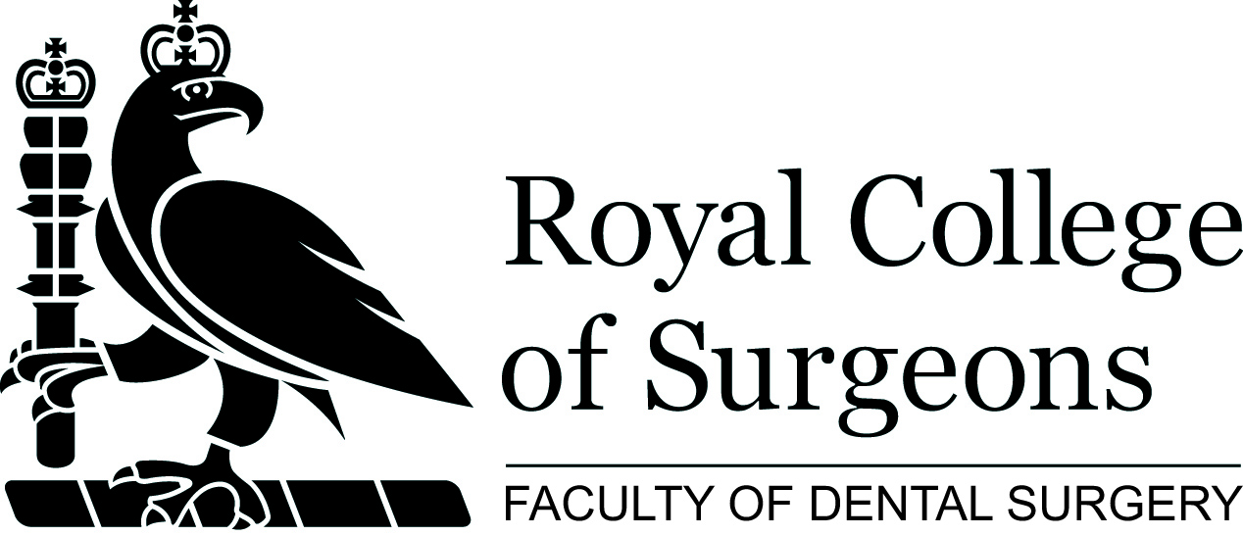

Becoming an Enrolled Member with FDS

In 1993 holders of existing College Diplomas and memberships were given an opportunity to become involved with the Faculty of Dental Surgery by paying an annual subscription and becoming enrolled members.
Becoming an enrolled member gives those practising dentistry a way of becoming actively involved in professional affairs and keep in touch with the Faculty and influencing the development of the dental specialties.

With your support the Faculty will be able to:
- Continue as the academic home for all dentistry and the dentally-based specialties
- Remain truly independent and authoritative for all the dentally-based specialties
- Campaign for high clinical standards
- Provide for the next and future generations of dentists and dental specialists
- Provide you a real opportunity to have a say in the future of your profession

Benefits

- Members’ welcome pack
- Discounts on selected Faculty courses and study days
- Regular receipt of the Annals, the College Bulletin and the Dean’s Newsletter
- Subscription to the Faculty Dental Journal (FDJ)
- Receipt of the quarterly Deans Newsletter
- Registration with the RCS(Eng) for Continuing Professional Development (CPD) and access to My CPD on the Faculty website.
- Free use of College facilities, including the Library, Lumley Study Centre and Members’ Lounge with free Wi-Fi, newspapers, tea and coffee
- FREE Hunterian Museum evening lectures for you and a guest
- FREE access to the Wellcome Museum of Anatomy and Pathology
- Discounted room and facility hire
- 20% off Nuffield accommodation
- RCS wedding venue discount
- FREE College diary
- 20% discount on any book from Cambridge University Press
- 20% discount on medicine titles from Oxford University press

Who is eligible to apply for Enrolled Membership?

Anyone who has D.Orth, DDPH or DSCD. Also anyone who has M.Orth or MCCD taken before 1993.

How to enrol?

Complete the following application form

I wish to become an enrolled Member of the Faculty of Dental Surgery

Title: *
Name:*
Address1: *
Address2:
Address3:
Town / City: *
Post Code: *
Country:
Specialty:*
Email Address: *
GDC Number: *
Telephone No: *
Qualification held: * | LDS / M.Orth (pre 1993) / MCCD (pre 1993) / D.Orth / DDPH / DSCD

Payment methods

Annual subscription to become an enrolled member is £234. Payment can be made by any of the following methods:

Paypal | 
Credit or Debit card | Please phone 020 7869 6093 during office hours (08:30 – 17:30)
Cheque | made payable to ‘The Royal College of Surgeons of England’ and returned to the address above.
Electronic bank transfer | Bank: C Hoare & Co,  Account Name: Stat Subs  Sort Code: 15 99 00, Account Number: 71155550  (IBAN No: GB27HOAB15990071155550, Swift code: HOABGB2L).  Please include your full name so that we can be sure to track your payment.

Data Protection

For the following statements, please tick as applicable:
I do not wish to receive updates from the College with regard to courses and events.

Bi-annually a list is produced for MBNA International Bank to promote the College ‘affinity’ credit card, please tick the box if you do not want this mailing.

This information will be held in accordance with the Data Protection Act 1998. It will be available to all College departments and may be shared with any relevant Specialist Associations located within the building, but not for commercial purposes.

